Terraform plan updates
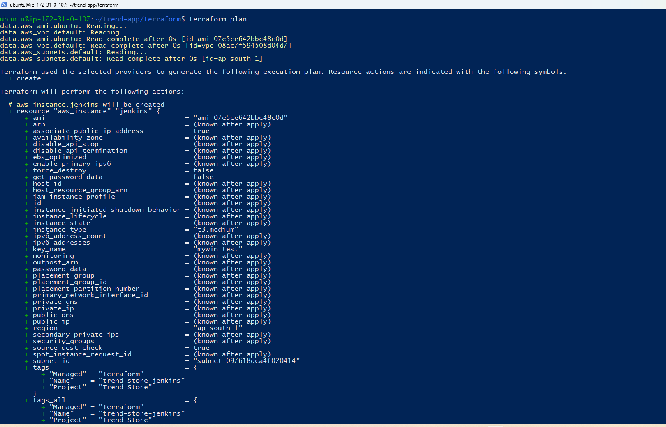
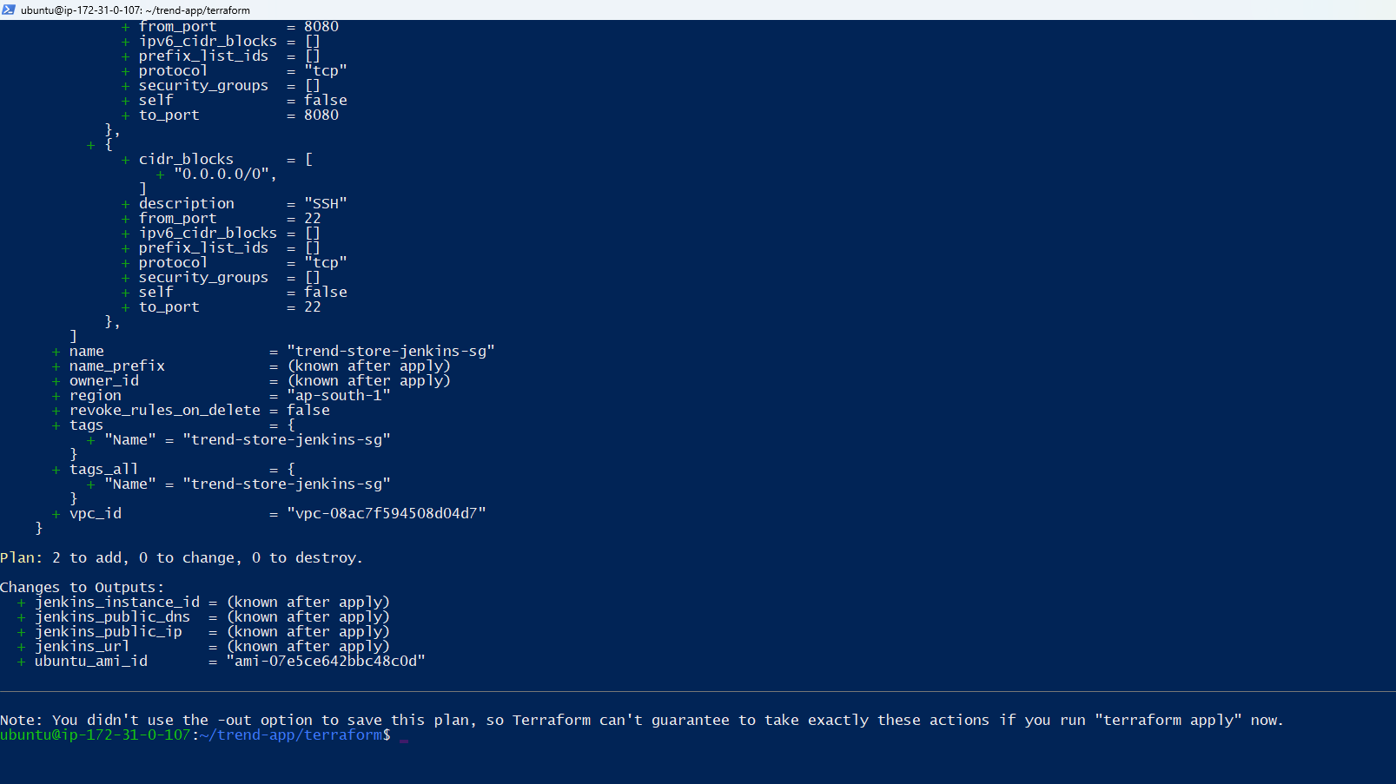

Terraform main.tf
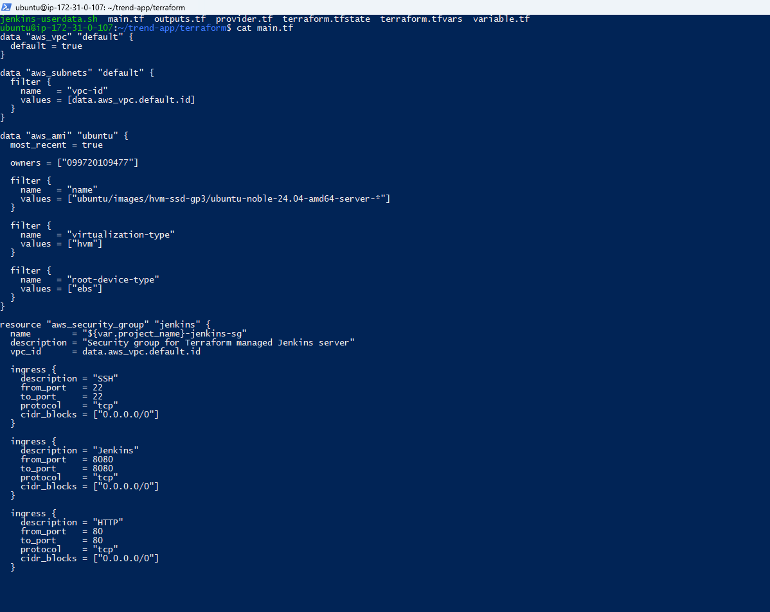
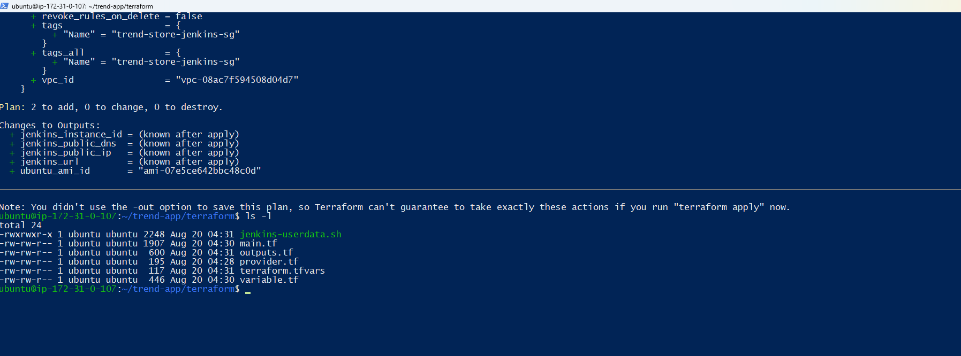terraform plan
data.aws_ami.ubuntu: Reading...
data.aws_vpc.default: Reading...
data.aws_ami.ubuntu: Read complete after 0s [id=ami-07e5ce642bbc48c0d]
data.aws_vpc.default: Read complete after 0s [id=vpc-08ac7f594508d04d7]
data.aws_subnets.default: Reading...
data.aws_subnets.default: Read complete after 0s [id=ap-south-1]

Terraform used the selected providers to generate the following execution plan. Resource actions are indicated with the following symbols:
+ create

Terraform will perform the following actions:

# aws_instance.jenkins will be created
+ resource "aws_instance" "jenkins" {
+ ami = "ami-07e5ce642bbc48c0d"
+ arn = (known after apply)
+ associate_public_ip_address = true
+ availability_zone = (known after apply)
+ disable_api_stop = (known after apply)
+ disable_api_termination = (known after apply)
+ ebs_optimized = (known after apply)
+ enable_primary_ipv6 = (known after apply)
+ force_destroy = false
+ get_password_data = false
+ host_id = (known after apply)
+ host_resource_group_arn = (known after apply)
+ iam_instance_profile = (known after apply)
+ id = (known after apply)
+ instance_initiated_shutdown_behavior = (known after apply)
+ instance_lifecycle = (known after apply)
+ instance_state = (known after apply)
+ instance_type = "t3.medium"
+ ipv6_address_count = (known after apply)
+ ipv6_addresses = (known after apply)
+ key_name = "mywin test"
+ monitoring = (known after apply)
+ outpost_arn = (known after apply)
+ password_data = (known after apply)
+ placement_group = (known after apply)
+ placement_group_id = (known after apply)
+ placement_partition_number = (known after apply)
+ primary_network_interface_id = (known after apply)
+ private_dns = (known after apply)
+ private_ip = (known after apply)
+ public_dns = (known after apply)
+ public_ip = (known after apply)
+ region = "ap-south-1"
+ secondary_private_ips = (known after apply)
+ security_groups = (known after apply)
+ source_dest_check = true
+ spot_instance_request_id = (known after apply)
+ subnet_id = "subnet-097618dca4f020414"
+ tags = {
+ "Managed" = "Terraform"
+ "Name" = "trend-store-jenkins"
+ "Project" = "Trend Store"
}
+ tags_all = {
+ "Managed" = "Terraform"
+ "Name" = "trend-store-jenkins"
+ "Project" = "Trend Store"
}
+ tenancy = (known after apply)
+ user_data = <<-EOT
#!/bin/bash

set -e

exec > >(tee /var/log/jenkins-userdata.log | logger -t user-data -s 2>/dev/console) 2>&1

echo "Starting Trend Store Jenkins server setup..."

apt-get update -y
apt-get upgrade -y

echo "Installing required packages..."

apt-get install -y \
ca-certificates \
curl \
gnupg \
unzip \
wget \
fontconfig \
openjdk-21-jre

echo "Installing Docker..."

install -m 0755 -d /etc/apt/keyrings

curl -fsSL https://download.docker.com/linux/ubuntu/gpg \
| gpg --dearmor -o /etc/apt/keyrings/docker.gpg

chmod a+r /etc/apt/keyrings/docker.gpg

echo \
"deb [arch=$(dpkg --print-architecture) signed-by=/etc/apt/keyrings/docker.gpg] https://download.docker.com/linux/ubuntu \
$(. /etc/os-release && echo "$VERSION_CODENAME") stable" \
> /etc/apt/sources.list.d/docker.list

apt-get update -y

apt-get install -y \
docker-ce \
docker-ce-cli \
containerd.io \
docker-buildx-plugin \
docker-compose-plugin

systemctl enable docker
systemctl start docker

echo "Installing Jenkins..."

mkdir -p /etc/apt/keyrings

wget -O /etc/apt/keyrings/jenkins-keyring.asc \
https://pkg.jenkins.io/debian-stable/jenkins.io-2026.key

echo "deb [signed-by=/etc/apt/keyrings/jenkins-keyring.asc] https://pkg.jenkins.io/debian-stable binary/" \
> /etc/apt/sources.list.d/jenkins.list

apt-get update -y

apt-get install -y jenkins

echo "Adding Jenkins to Docker group..."

usermod -aG docker jenkins

systemctl enable jenkins
systemctl restart jenkins

echo "Installing AWS CLI..."

curl "https://awscli.amazonaws.com/awscli-exe-linux-x86_64.zip" \
-o /tmp/awscliv2.zip

unzip -q /tmp/awscliv2.zip -d /tmp

/tmp/aws/install

echo "Installing kubectl..."

curl -LO "https://dl.k8s.io/release/$(curl -L -s https://dl.k8s.io/release/stable.txt)/bin/linux/amd64/kubectl"

install -o root -g root -m 0755 kubectl /usr/local/bin/kubectl

rm -f kubectl
rm -f /tmp/awscliv2.zip

echo "Verifying installations..."

java -version
docker --version
aws --version
kubectl version --client
systemctl --no-pager status jenkins || true
systemctl --no-pager status docker || true

echo "=============================================="
echo "Trend Store Jenkins server setup completed"
echo "=============================================="
EOT
+ user_data_base64 = (known after apply)
+ user_data_replace_on_change = false
+ vpc_security_group_ids = (known after apply)

+ capacity_reservation_specification (known after apply)

+ cpu_options (known after apply)

+ ebs_block_device (known after apply)

+ enclave_options (known after apply)

+ ephemeral_block_device (known after apply)

+ instance_market_options (known after apply)

+ maintenance_options (known after apply)

+ metadata_options (known after apply)

+ network_interface (known after apply)

+ primary_network_interface (known after apply)

+ private_dns_name_options (known after apply)

+ root_block_device {
+ delete_on_termination = true
+ device_name = (known after apply)
+ encrypted = (known after apply)
+ iops = (known after apply)
+ kms_key_id = (known after apply)
+ tags_all = (known after apply)
+ throughput = (known after apply)
+ volume_id = (known after apply)
+ volume_size = 20
+ volume_type = "gp3"
}

+ secondary_network_interface (known after apply)
}

# aws_security_group.jenkins will be created
+ resource "aws_security_group" "jenkins" {
+ arn = (known after apply)
+ description = "Security group for Terraform managed Jenkins server"
+ egress = [
+ {
+ cidr_blocks = [
+ "0.0.0.0/0",
]
+ description = "Allow outbound traffic"
+ from_port = 0
+ ipv6_cidr_blocks = []
+ prefix_list_ids = []
+ protocol = "-1"
+ security_groups = []
+ self = false
+ to_port = 0
},
]
+ id = (known after apply)
+ ingress = [
+ {
+ cidr_blocks = [
+ "0.0.0.0/0",
]
+ description = "HTTP"
+ from_port = 80
+ ipv6_cidr_blocks = []
+ prefix_list_ids = []
+ protocol = "tcp"
+ security_groups = []
+ self = false
+ to_port = 80
},
+ {
+ cidr_blocks = [
+ "0.0.0.0/0",
]
+ description = "Jenkins"
+ from_port = 8080
+ ipv6_cidr_blocks = []
+ prefix_list_ids = []
+ protocol = "tcp"
+ security_groups = []
+ self = false
+ to_port = 8080
},
+ {
+ cidr_blocks = [
+ "0.0.0.0/0",
]
+ description = "SSH"
+ from_port = 22
+ ipv6_cidr_blocks = []
+ prefix_list_ids = []
+ protocol = "tcp"
+ security_groups = []
+ self = false
+ to_port = 22
},
]
+ name = "trend-store-jenkins-sg"
+ name_prefix = (known after apply)
+ owner_id = (known after apply)
+ region = "ap-south-1"
+ revoke_rules_on_delete = false
+ tags = {
+ "Name" = "trend-store-jenkins-sg"
}
+ tags_all = {
+ "Name" = "trend-store-jenkins-sg"
}
+ vpc_id = "vpc-08ac7f594508d04d7"
}

Plan: 2 to add, 0 to change, 0 to destroy.

Changes to Outputs:
+ jenkins_instance_id = (known after apply)
+ jenkins_public_dns = (known after apply)
+ jenkins_public_ip = (known after apply)
+ jenkins_url = (known after apply)
+ ubuntu_ami_id = "ami-07e5ce642bbc48c0d"

Terraform Apply
terraform-plan.png
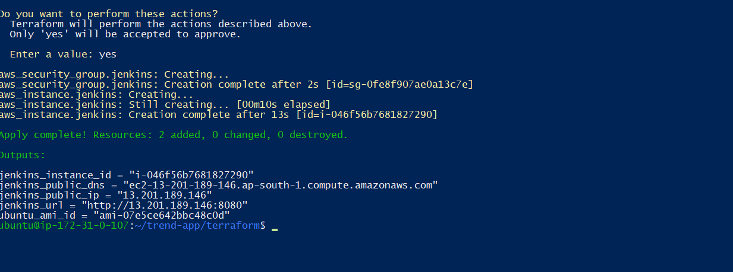
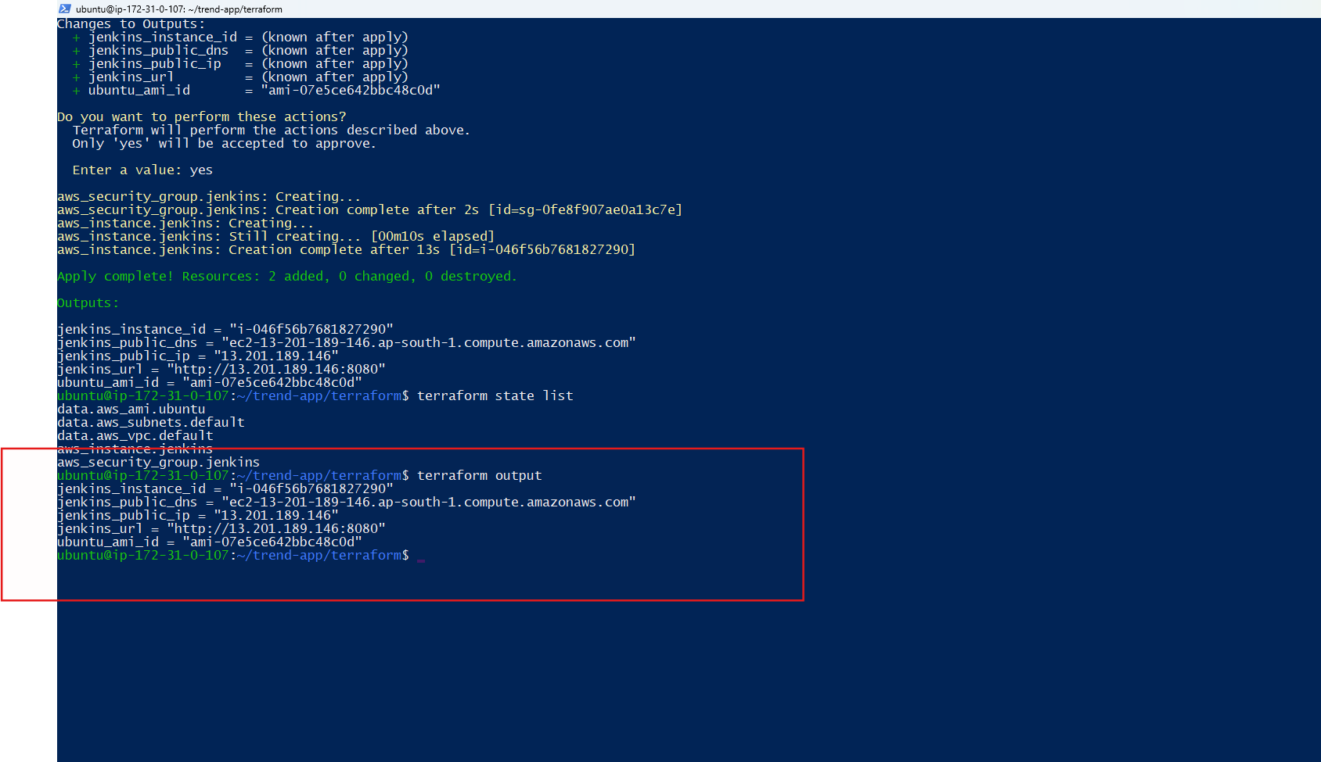
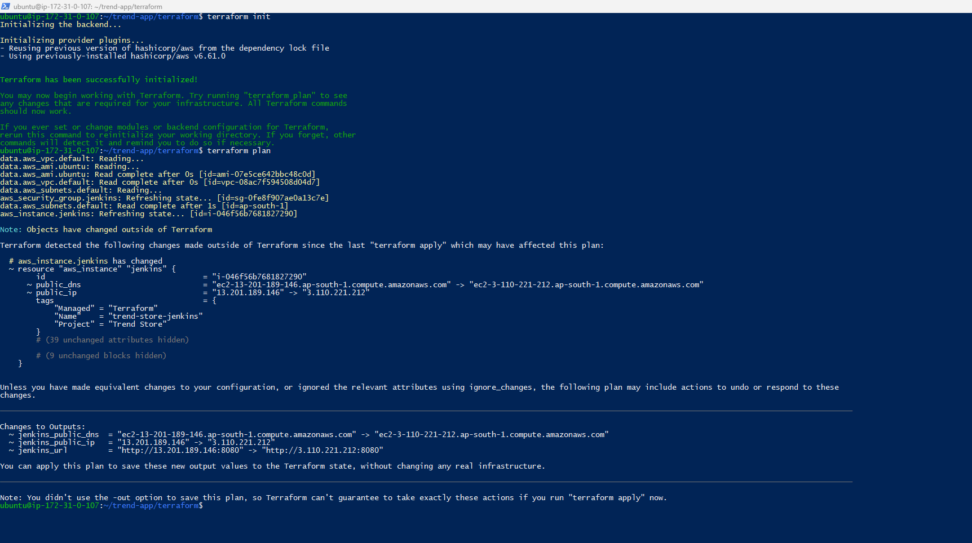
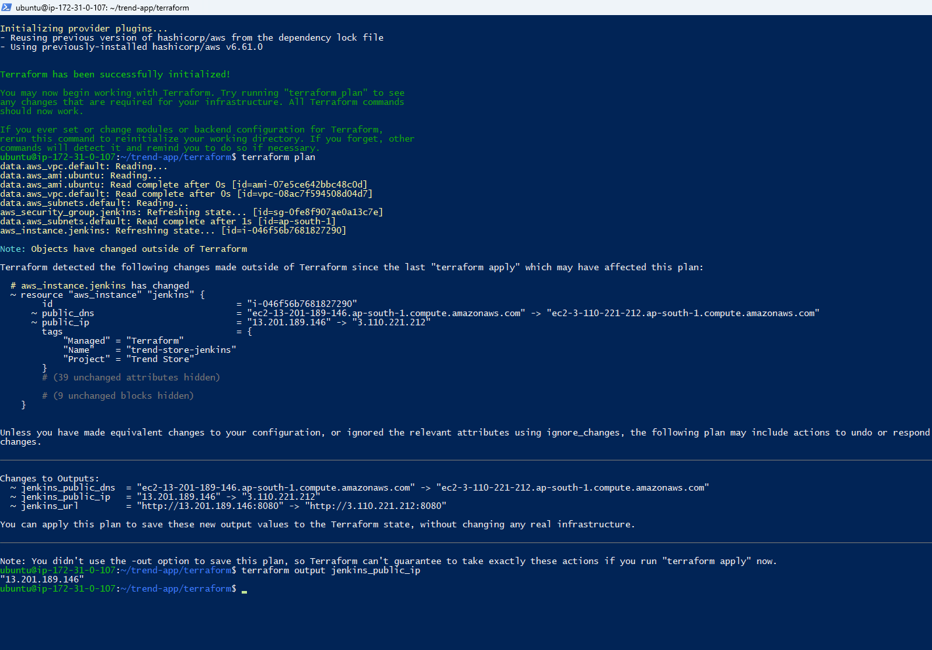
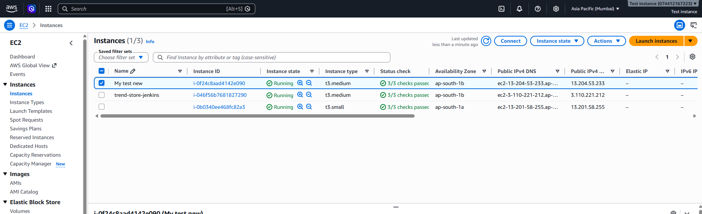

EKS cluster status
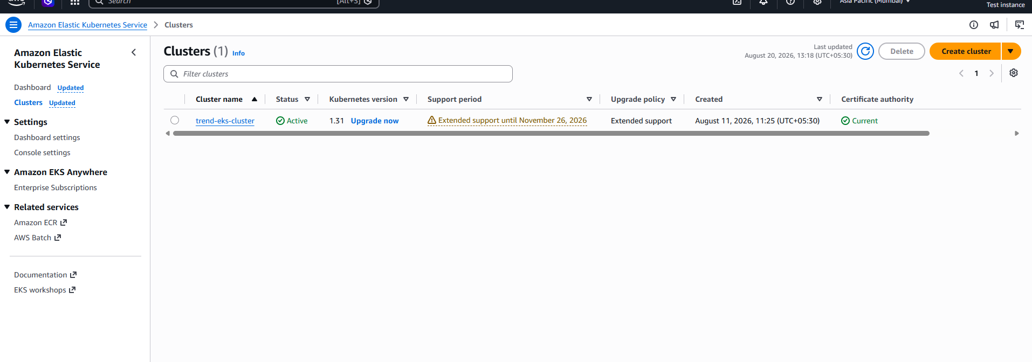
- Load balancers
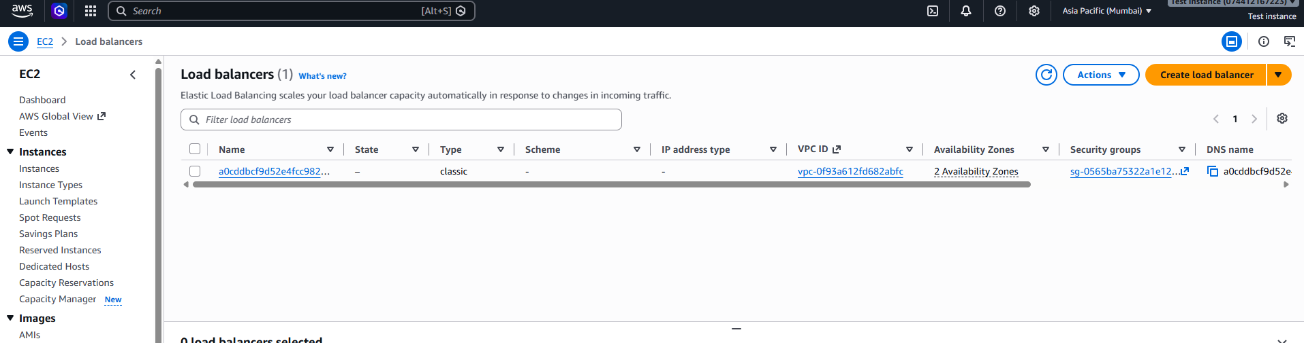

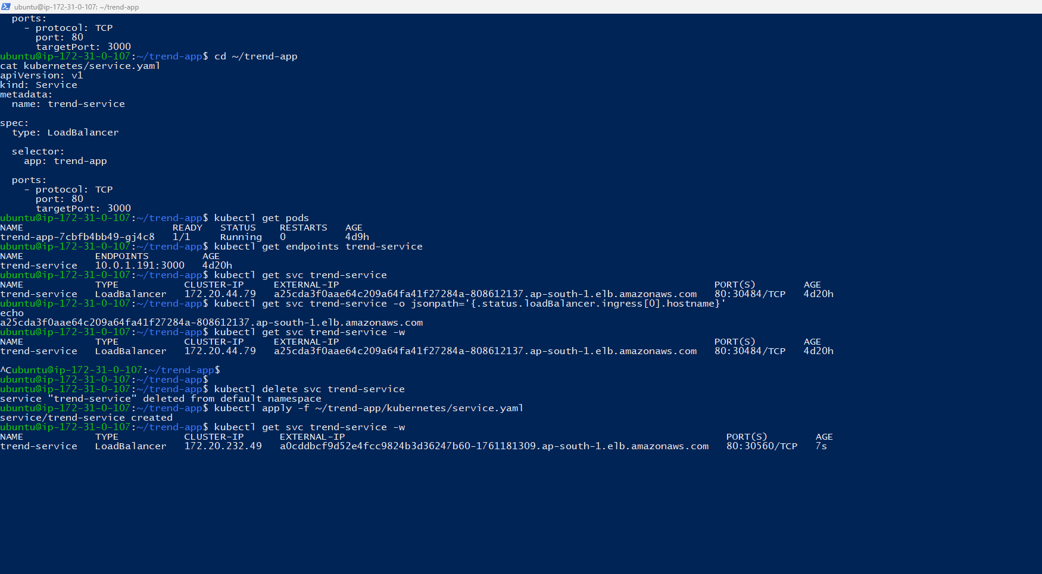
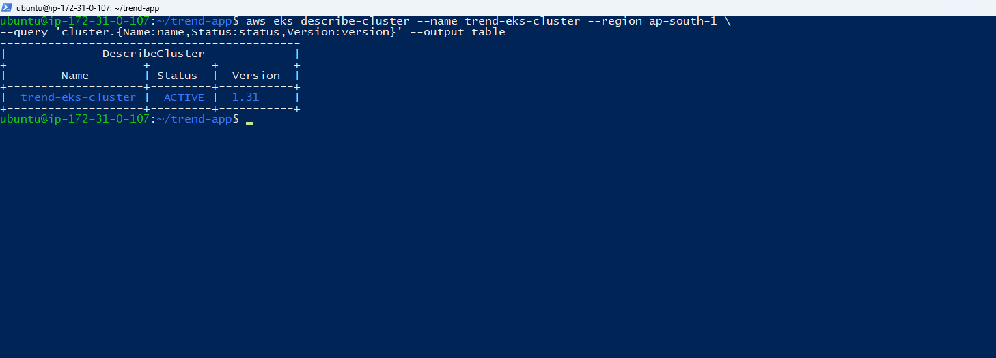
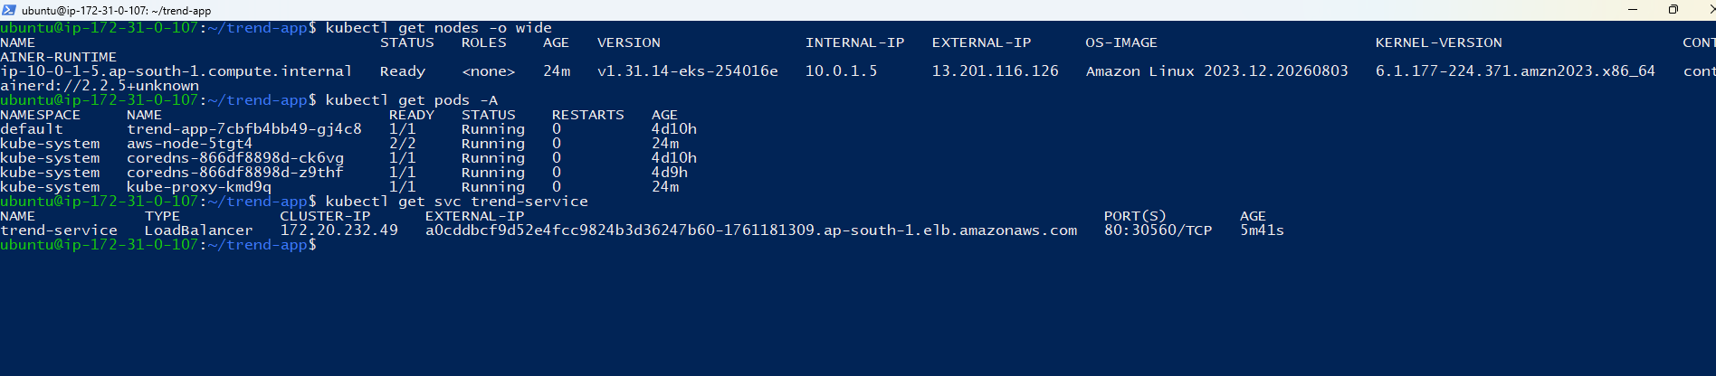


- Successfully added the Monitor part and below are the attached screenshots
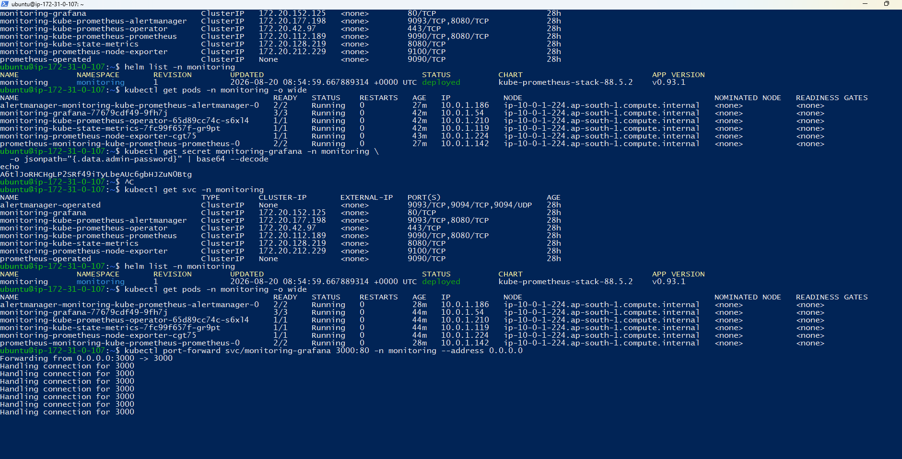
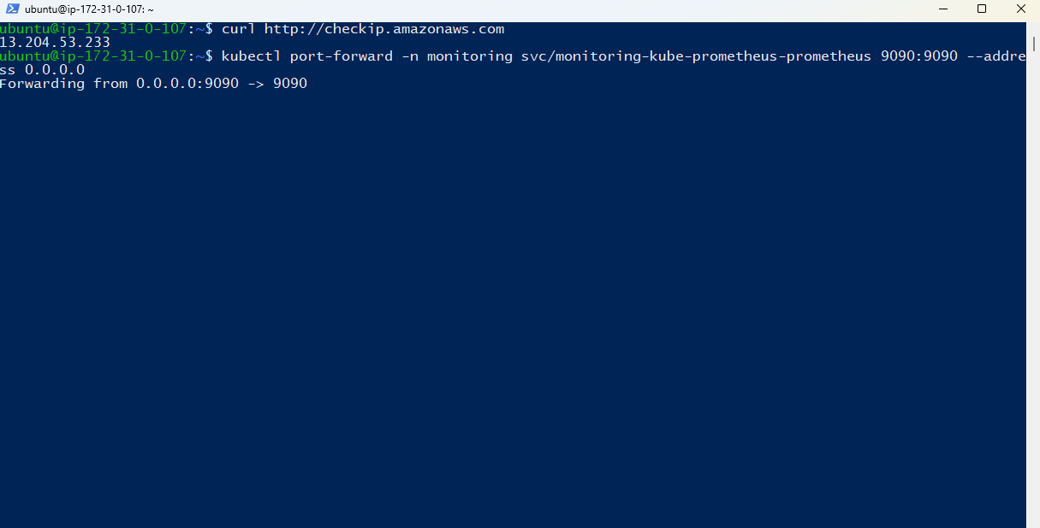
Monitoring Part Screenshots
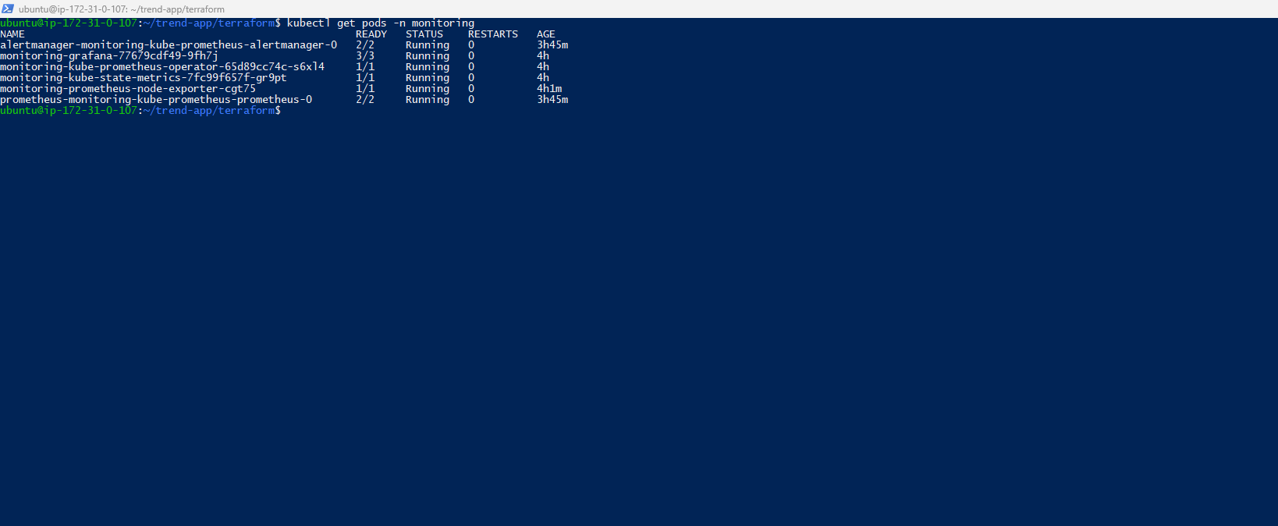
CPU utilization of your EKS node.
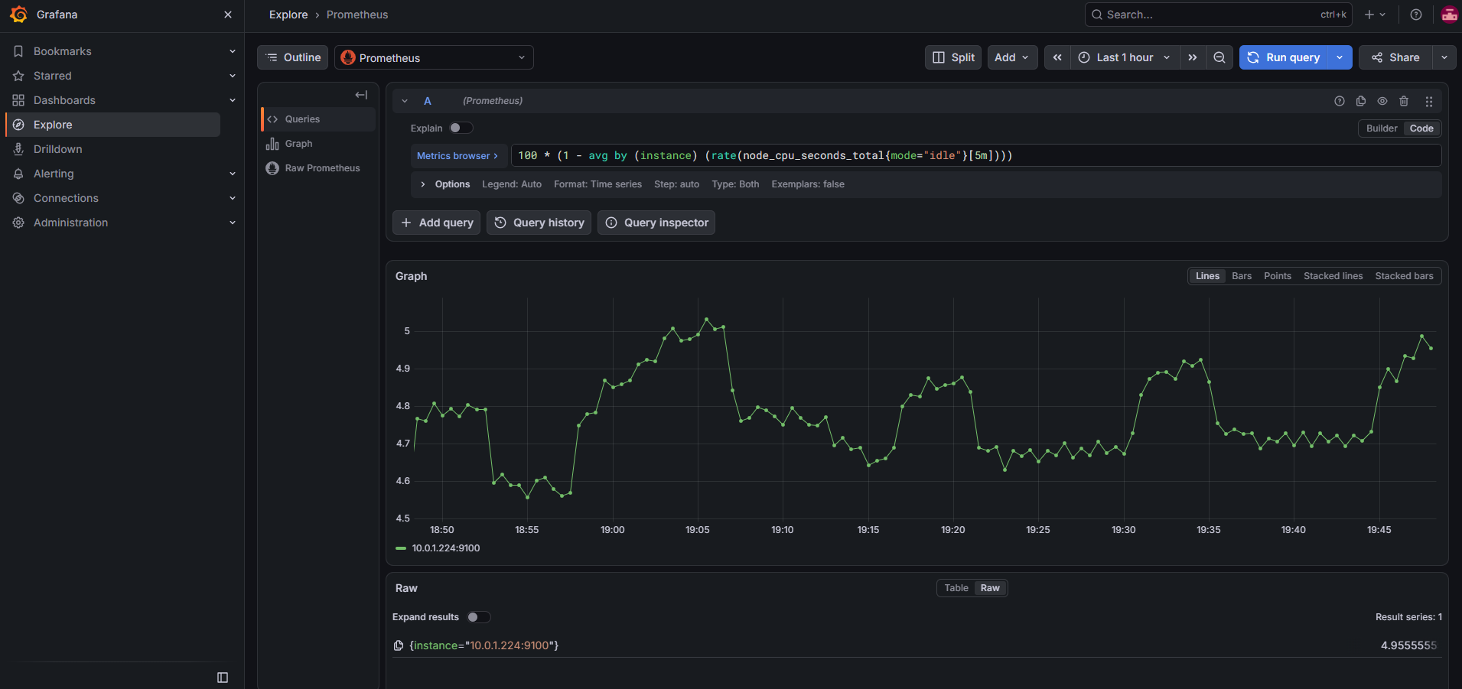
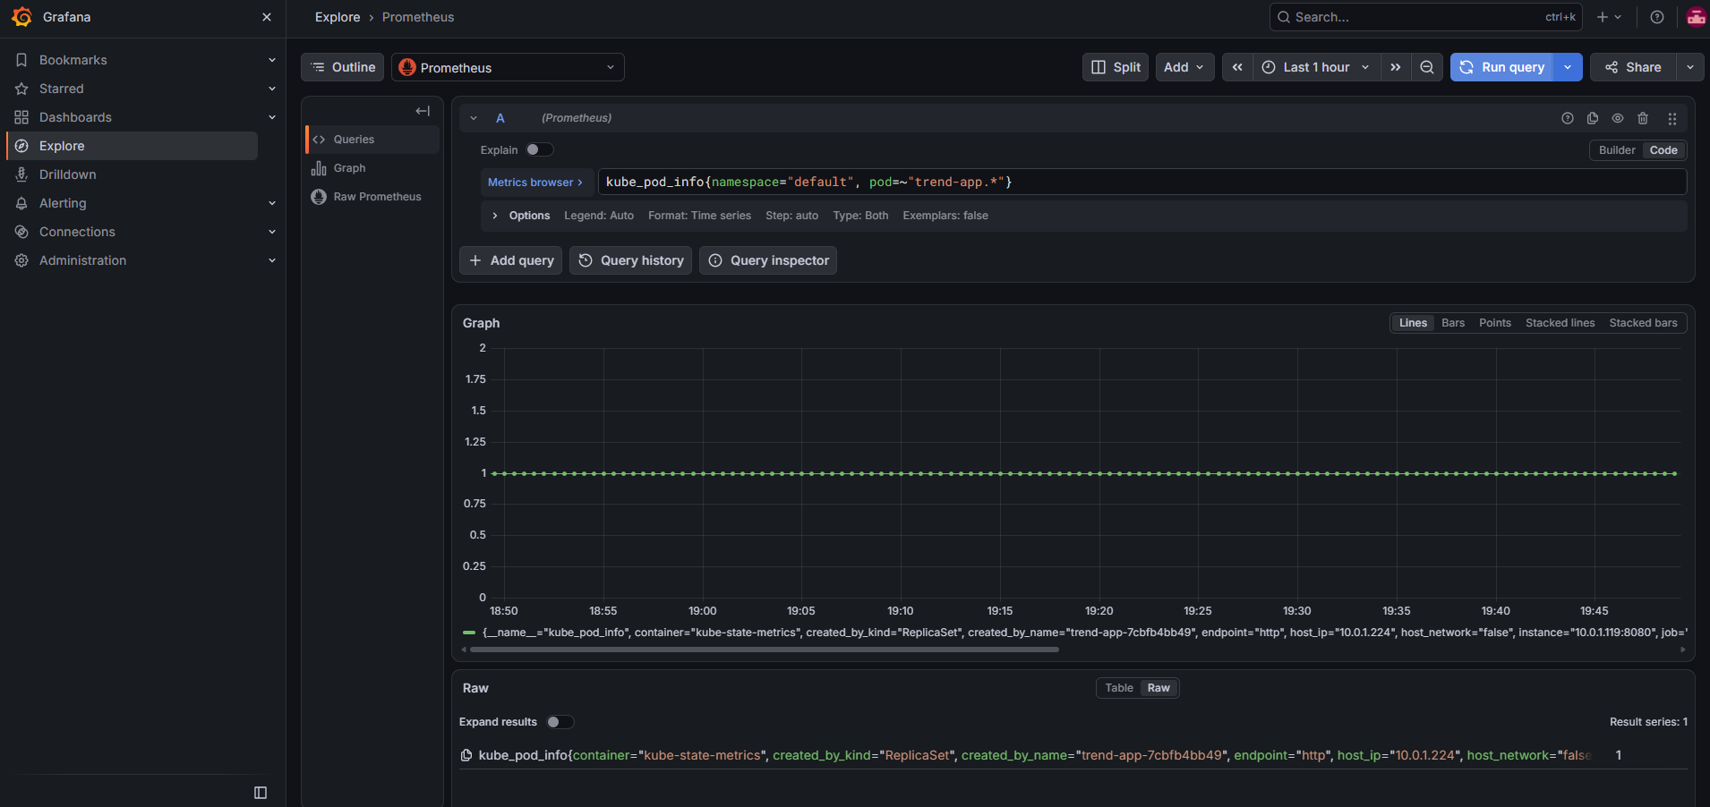

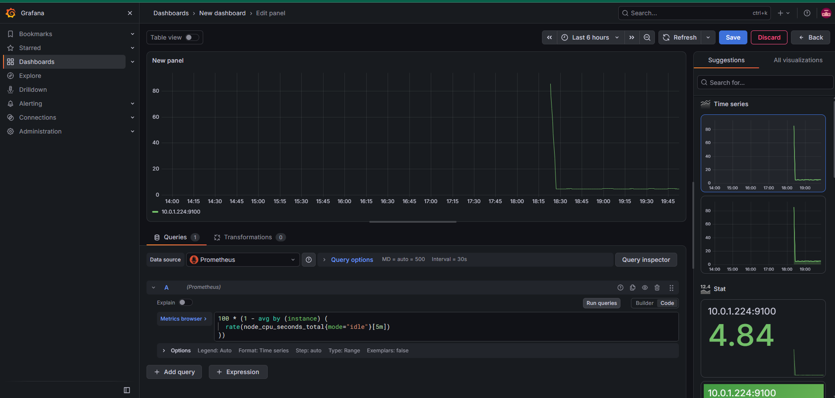
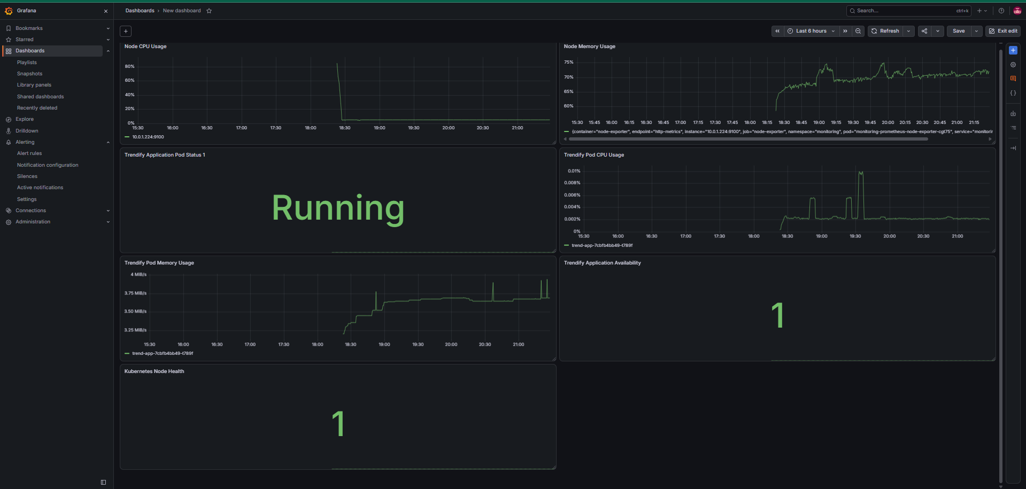
Also I have added the external link of the Monitoring module
http://localhost:3000/public-dashboards/069de46fad404521a8de7ce4be0700b6
http://localhost:3000/dashbo9ard/snapshot/WcFobXA2vChvbBlYsC2ukzvVNUo3VWcK

